Sri Lanka: Lessons of Urban Agriculture for Rural Applications with Family Business Gardens

Dr. Thilak T. Ranasinghe
Consultant [Freelance]
Urban Agriculture/Rural Livelihoods
[Fmr. Director of Agriculture (Western), Sri Lanka]
thithura@sltnet.lk

The economy of a country is to be developed for improved livelihoods in urban as well as rural areas in the context of a sustainable economy. Sri Lanka expects high economic growth and per capita GDP in the process of economic growth after the end of long years of civil war.
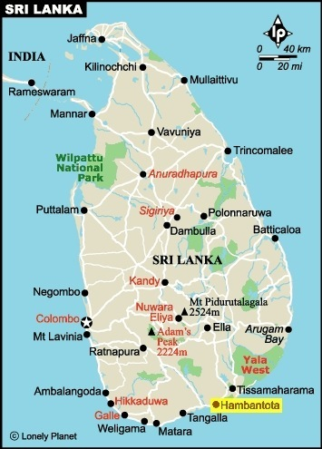
In Sri Lanka, especially in the Southern rural district of Hambantota has been converting from the status of rural to an urban position along with mega infrastructural development process being taken place since immediate past. For instance, construction of first ever Sea Water-Filled Harbor of the world, Oil Tank farm, International Cricket Ground, International Conventional Centre, International Air Port, Administrative Complex, Dry-Zone Botanical Gardens and highway road-cum-railway networks are some major contributing factors in this process.
In consequence, forest covers and agricultural lands have been diminishing with some problems in relation to the depletion of natural resource base namely water availability, water quality, unexpected weather patterns, reduction in landholding sizes and conflicts associated with wildlife. However, it seems that conditions are becoming close to the situation existed in the Colombo district (i.e., capital city is located in the Colombo district within the Western Province of Sri Lanka) that carries high rates of problems related to urbanization and conflicts in resource utilization processes.
The Western Province that carries high population pressure in the country enjoys the experience of the concept of the Family Business Garden [FBG] in the context of urban agriculture [UA], since 2000 (see the box below for the essence of the FBG concept). The concept advocates UA by unleashing the creativity embedded in urban dwellers to utilize not only the horizontal space but also the vertical space for agriculture under resource poor situations. It promotes the use of “Vertical Living Cultivation Structures” in maximizing vertical space of small homesteads while improving family nutrition and income within the process of sustainable development.

Box: - Components of the Concept of the Family Business Garden [FBG]
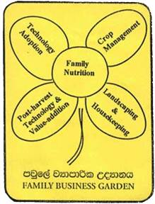
The concept of the FBG expects to provide an alternative to “subsistence form of home-gardening” through agricultural entrepreneurship attempts for additional income generation on the basis of sustainable livelihood improvement strategies. This concept is flexible as well as creative while being not confine to a fixed model.
The concept is depicted herewith the “Brand Flower” which carries five petals primarily based on family nutrition. The dual stalk symbolizes the environmental and/or commercial agriculture which provides opportunity to implement entrepreneurship as homestead owner wishes. It is really a simple concept. The five fold strategies and activities shown in the logo flower are given below:
i) Family Nutrition: - Select nutritious and favorite crops in considering limited resources according to the choice of family members. It is expected to enter through hygienically protective measures for production and/or processing processes. The creativity is stressed in advancing the vertical cultivation methods in implementing and maintaining homestead management processes. It stresses the utilization of “Live Cultivation Structures” in developing homestead as appropriate.
ii) Technology Adoption: - It is recommended to pay attention for the number of family members, available members for gardening and financial capacity for investment in working on a better mix of indigenous technical know-how and scientific intensive farming techniques. Also involves with technology development process through experience collected. It advocates going for new as well as local crops which have a demand in increasing incomes. It manages the market challenges by forming into groups.
iii) Crop Management: -It is required to organize well in advance for soil, water, sunlight and pest management measures for sustainability. It is a must to do waste management and recycling of plant nutrients. Wherever possible, livestock management is advocated along with integrated farming practices. The use of compost, carbonized paddy husk, liquid manure applications as well as water conservation and harvesting strategies are highly stressed.
iv) Postharvest technology and value addition: - In planning the homestead one has to pay attention to this aspect too. Different income generation strategies by excess production are encouraged. Although products are from homesteads quality must be maintained in good standards. It is important to be sensitive with ever-changing consumer behavioral patterns while producing different value added products for the market. Entrepreneur benefits by lowering the postharvest losses are motivated and continually stressed.
v) Landscaping and housekeeping: - In the context of current environment, social and economic surroundings mental unrest is common in urban as well as rural settings. The calm and tranquil environment had in the past is no more available in rural villages to day. Thus, opportunity is available to create suitable edible landscapes in homesteads with a mixture of flower and ornamental plants with the combination of vegetable and fruit plants. It further promotes to improve physical as well as mental health. In improving housekeeping aspect, organization of the house from verandah to the kitchen is also stressed.
PS:-For more details about the concept of the FBG and creative simple cultivation structure preparations find the online version of the “Manual of Low/No-Space Agriculture -cum- Family Business Gardens” in http://www.iwmi.org/Publications/Other/Manuals/FBG_Manual.pdf

Rural districts like Hambantota as indicated earlier can learn those experiences of the concept of the FBG within the goals of livelihood improvement so as to utilize opportunities in the context of restricted resource utilization. There are five areas that can immediately be applied for rural and sub-urban community development works as different communities positively respond to the essence of the concept of the FBG in varying scales and interests. Let us briefly discuss those experiences in the following manner:
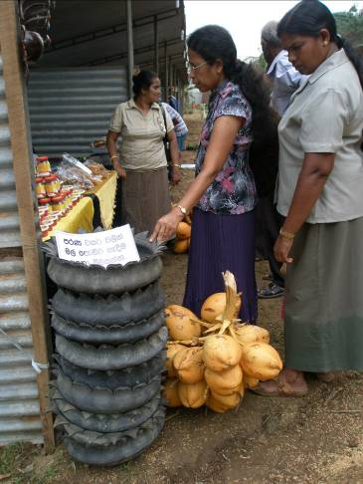
1. In meeting land area limitations: - The demand for land is on the increase as the urbanization process is heading by creating new employment accesses other than agriculture and entrepreneurship opportunities in the arena of industrialization. It is also not economically sound to keep lands under barren/fallow status while opportunity is opened for dividing into small parcels against the increased demand for lands under newly created challenges and opportunities for urban environments. However, it is observed that the disastrous experience of tsunami, in 1994 caused to make a shift of preference for architectural designing from single to two-storey houses even at interior areas that land space is not a serious problem for housing.
Cultivation Crater
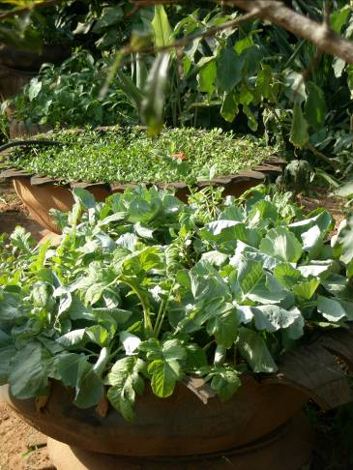
In consequence, opportunity to use vertical farming methods while having a better mix of indigenous technical know-how and scientific knowledge is on the increase as the level of heterogeneity is raised with diverse forms of creativity available among different communities. In rural areas along with the use of heavy machinery and equipment for infrastructure development activities, discarded tyres are reused to build new cultivation structure called “Cultivation Crater” in the Hambantota district. It primarily helps to save water use and could be an effective answer to cultivate on low fertile or eroded soils with high production efficiency. Also those items are easy to protect from wildlife as structures are placed within homesteads. This creativity is further strengthened and expanded into small vehicle tyres like three-wheeler tyres and the adoption rate has also risen with the popularity. This novelty has opened up for new income generation access as selling of Cultivation Craters at village fairs and exhibitions are taken place.
Cultivation Craters for sale
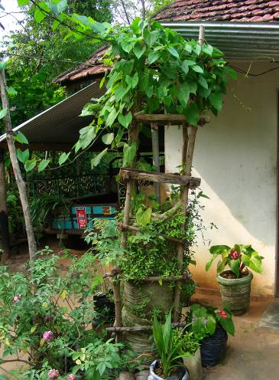
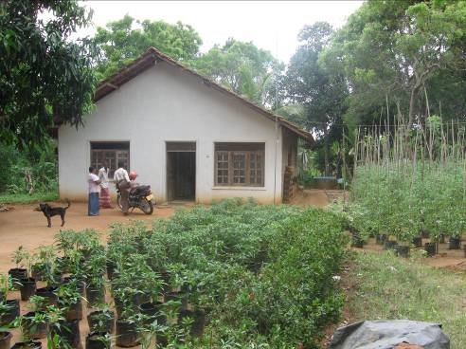
2. In addressing water stress conditions: - The availability of water is difficult, different and varied from place to place in rural settings which are unlike to pipe-born water availability in urban areas. In the practice of soil and water conservation strategies watershed management is the key aspect in the process of rural development. However, in urban areas water management is closely associated with flood protection -cum- drainage arrangements and concentrated on individual homestead basis rather than community orientations.
Modified Cultivation Tower
Cultivation Bags in saving water
The use of cultivation structures such as Cultivation bags, Cultivation Towers and Cultivation Bottles are becoming popular among rural communities in saving water while producing vegetables and fruits for family food security as well as earning money on commercial terms. They save water and further improve crop sanitation by adding carbonized paddy husk collected from rice mills.
Also rural and suburban communities adopt micro-irrigation technologies applicable in optimizing water use in commercial agricultural fields as well as in homesteads where water come from lift irrigation water sources. However, rain is the key deciding factor in resource poor rural areas and water harvesting practices adopted on scattered basis. The use of artificial shade nets for high value crop cultivation is a novel inclusion that can be seen even at the homestead levels and also a positive trend in absorbing UA technologies for rural settings especially in the district like Hambantota.
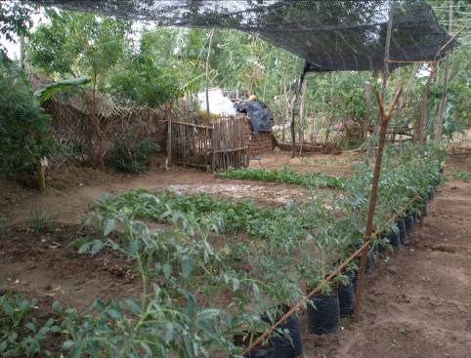
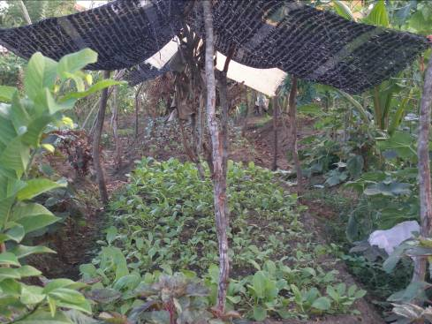
3. In overcoming poor soil conditions: - Landscape is the key natural resource in horizontal farming practices. When there is low fertility in soils, ill drain situations and saline conditions homestead cultivation becomes a problem for attractive edible landscape building. Thus, one has to take rectifying measures to overcome those situations for better yields and incomes. Application of compost, cutting drains, making raised beds, dolomite application and the like are examples for those measures. Also availability of vertical cultivation methods does lead to think differently and act on alternative -cum- creative manner in overcoming such situations faced at small homesteads. The use of vertical cultivation structures in homesteads is a new strategy and one has to handle with family interests but it is being backed by the government policy on Urban Agriculture under the national cultivation campaign namely “Let us cultivate to build the nation,” by now. It is a new experience for rural areas and requires appropriate as well as dynamic extension strategies in reaching communities who undergo the process of urbanization.
Compost & dolomite in improving soils
In vertical farming strategies “living compost frame” adopted from the practice of urban agriculture is becoming popular among rural as well as resource poor remote areas. It helps to keep hygienically clean homesteads as well as to generate effective growth media for homestead cultivations cheaply and easily as stated by many Hambantota small homestead owners with great confidence. It caters the need of periodical refilling of growth media required by vertical cultivation structures. It facilitates the home composting process that continues without any interruption under sustainable development initiatives.
Use of shade-nets in homesteads
4. In minimizing human–wildlife conflicts: - The devastation actions of wildlife habitats for the sake of development is being progressed in fast developing as well as urbanizing areas. As a result, elephants roam into populated areas often in searching for lost food quotas in the wild and even go after urban waste filling locations. In so doing, elephants confront humans and usually attack homestead crops and household food stocks while making threatening to environment and human lives.
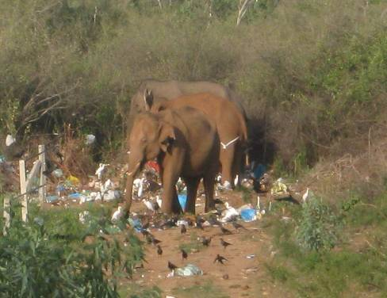
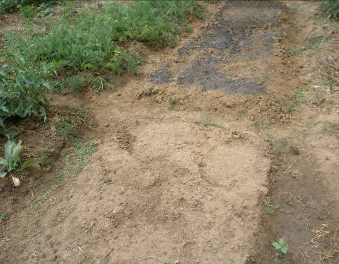
In mitigating such situations electric fencing is frequently recommended for quick results or protection from wild elephants so as to reduce human-elephant conflicts. However, it requires proper and regular maintenance for effective safety of both wildlife and human beings. It is also experienced that there are some repellant crops such as cactus, citrus and bougainvillea that can be cultivated in reducing attacks but in micro-scale with proper after care and attentiveness.
Elephant footprints in a homestead
Elephants going after urban waste
If vertical cultivation structures are adopted by small homestead owners they can maximize homestead space while allocating some space for wilderness without being under utilized by man made interventions. However, people still try to exploit rural land spaces for slash and burn cultivations in aggravating the conflicting situations and restricting food sources for wildlife. As a result it is realized that small space cultivations should be popularized in protecting the wilderness and also in improving biodiversity through edible land-scaping and air-scaping technologies advocated through the concept of the FBG.
5. In compromising with life style changes: - The globalization process and improved information communication technology networks cause changes in rural lives at least in moderate levels along with urbanization forces. Those aspects resulted to make impact on food habits, physical fitness, fashion design styles, leisure spending and saving patterns of rural dwellers. Those changes are in varying scales from positive terms to negative terms in making different development interests.
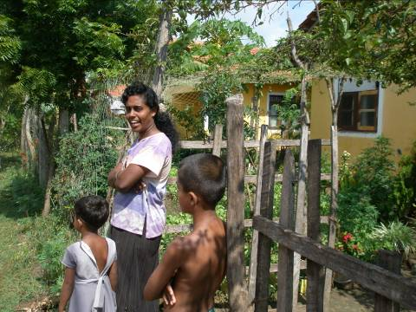
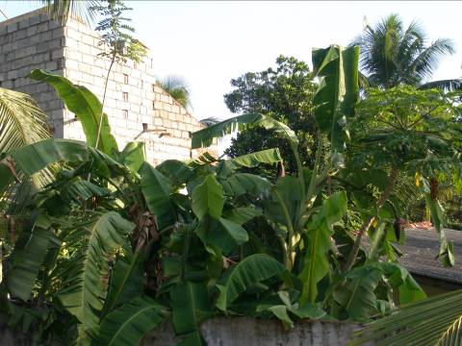
The awareness on human health, hygiene and sanitation lead to adjust rural communities, specifically youth in tuning up with current trends and living patterns while moving out of traditional norms and values. In relation to the UA initiatives, inclusion of slow-burning foods like green vegetables and fruits into the food habits with higher potions than in the past induces the adoption of vertical cultivation structures in homestead development measures. Those measures go along with nutritious food crops or with functional food production strategies which provide easy access to meet family consumption needs and growing opportunities for niche markets in the process of agro-entrepreneurship development.
Two-storey house under construction
Lifestyles under changing position
All in all, it is understood that urban agriculture helps to create urban-rural continuum in developing the useful measures for living in harmony under stressful situations by being working with nature, built environment and heterogenic communities. It improves family nutrition, household food security status and family income while reducing physical and mental stress, cost of family food basket and conflicting situations related to environment management with creative and productive manner.

*****

